Original | Reconstruction  PSNR: 30.9803  MS-SSIM: 0.9580 | 2 subpackages dropped  PSNR: 27.7293  MS-SSIM: 0.9359 | 2 subpackages patched  PSNR: 27.8985  MS-SSIM: 0.9373
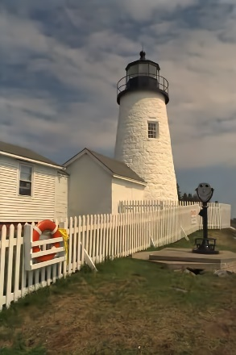 |  | 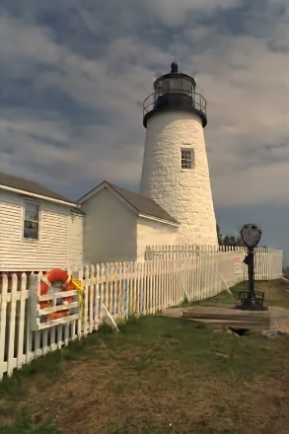 | 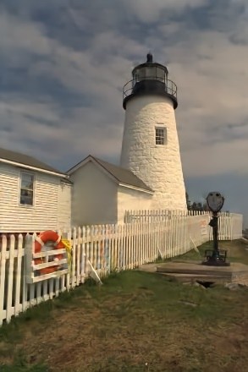
4 subpackages dropped  PSNR: 19.2529  MS-SSIM: 0.8600 | 4 subpackages patched  PSNR: 23.1151  MS-SSIM: 0.8896 | 8 subpackages dropped  PSNR: 15.5363  MS-SSIM: 0.7488 | 8 subpackages patched  PSNR: 19.2775  MS-SSIM: 0.7869
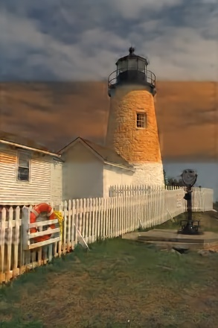 | 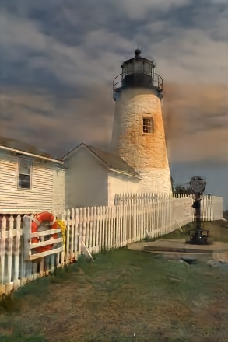 | 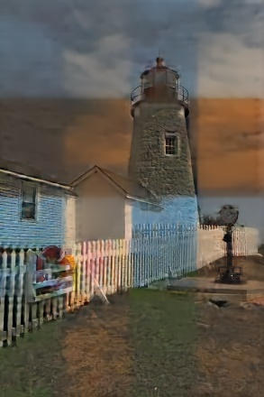 | 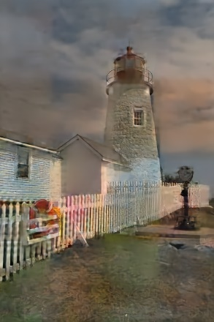

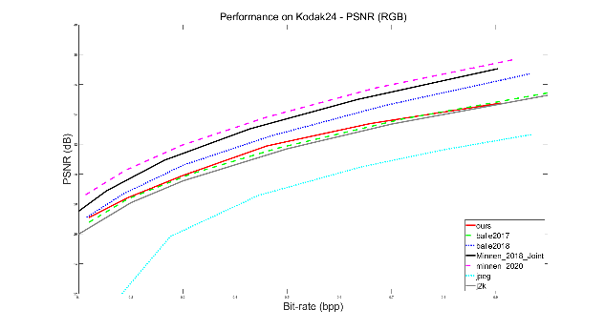 | 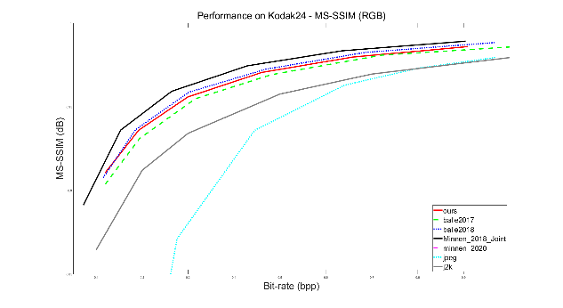

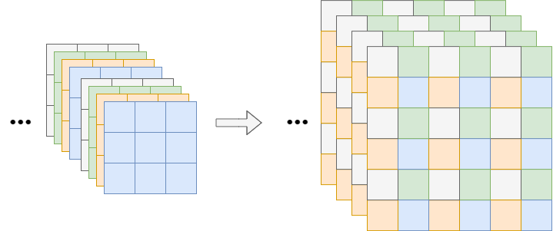
- Before pixelshuffle | - After pixelshuffle

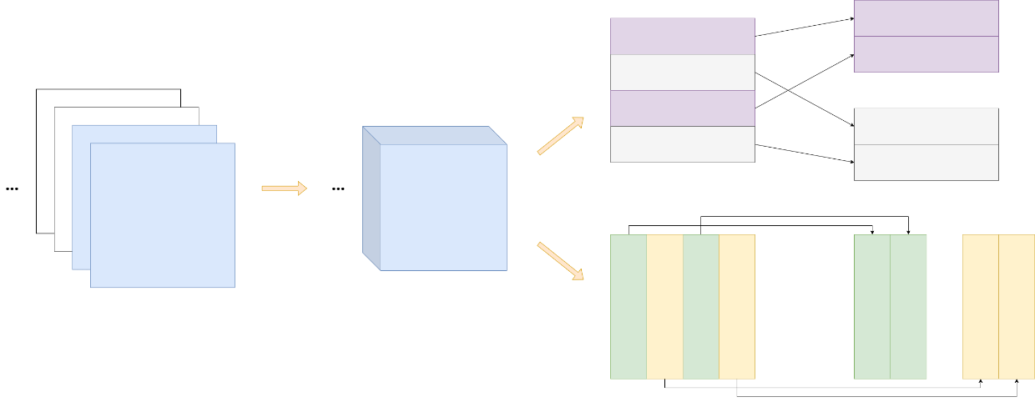
- Before slicing | - Slices | - Segmentation

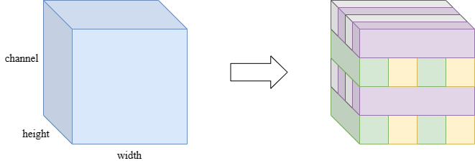
- Before subpackage layer | - After subpackage layer

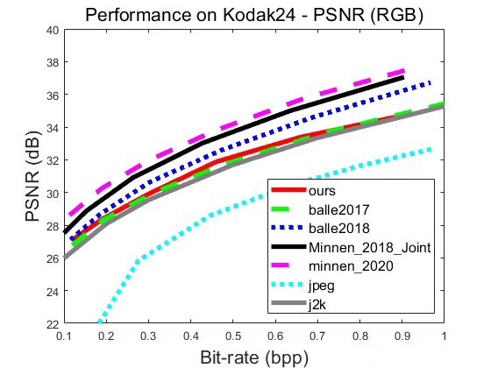 | 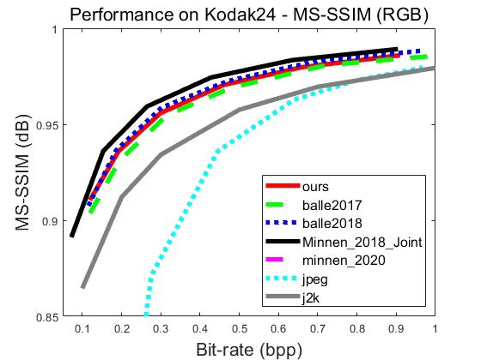

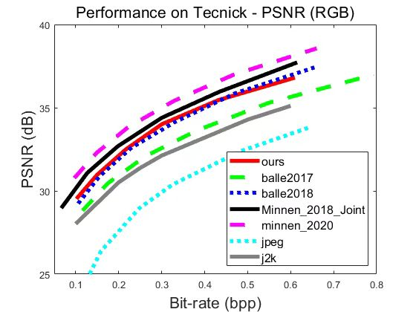 | 